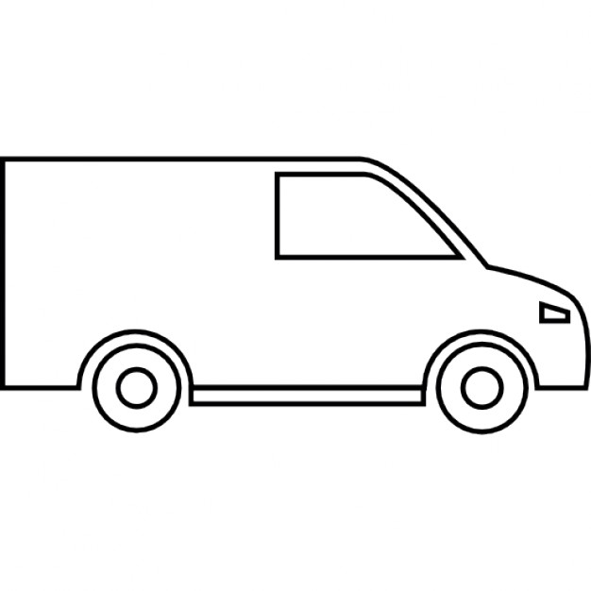
I do lots of jobs

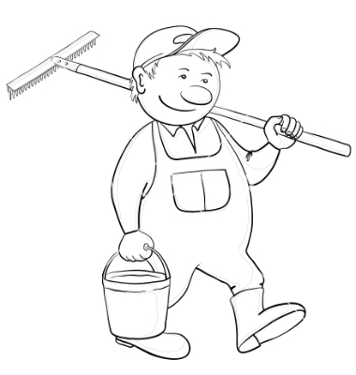

Dan has a lot of jobs to do.

Dan has a big red van.
red mat.

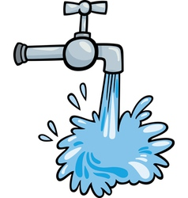
My Home Reader


Dan can fix the tap and put the bags in the bin.

This is Dan the man.

