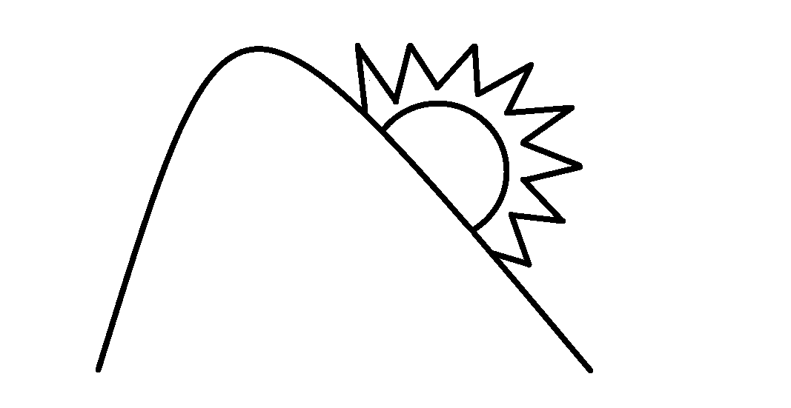
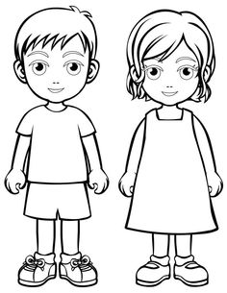

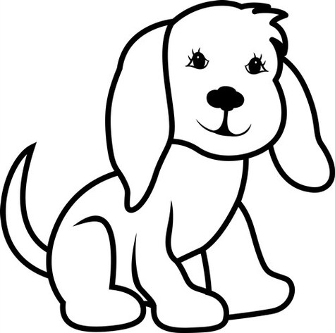

Jack had a big dog.
The dog is ten.

Jack and Jill went up a hill in the sun.
red mat.

My Home Reader
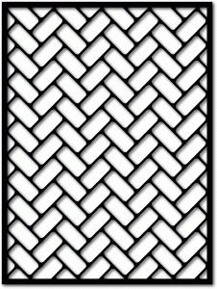

Jack and Jill sat on a rug with Bill the dog.

This is Jack and Jill.

