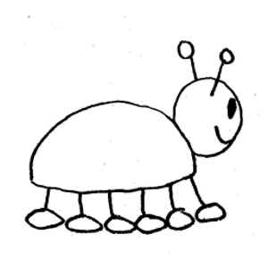
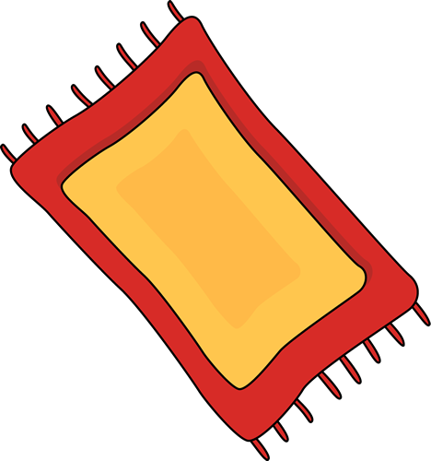
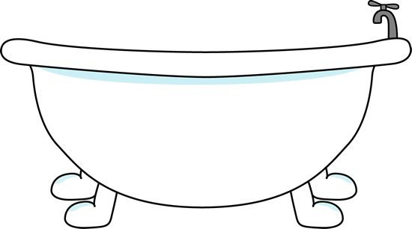

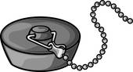

He went in the tub and sat on the plug!

Zug the bug sat on the rug.

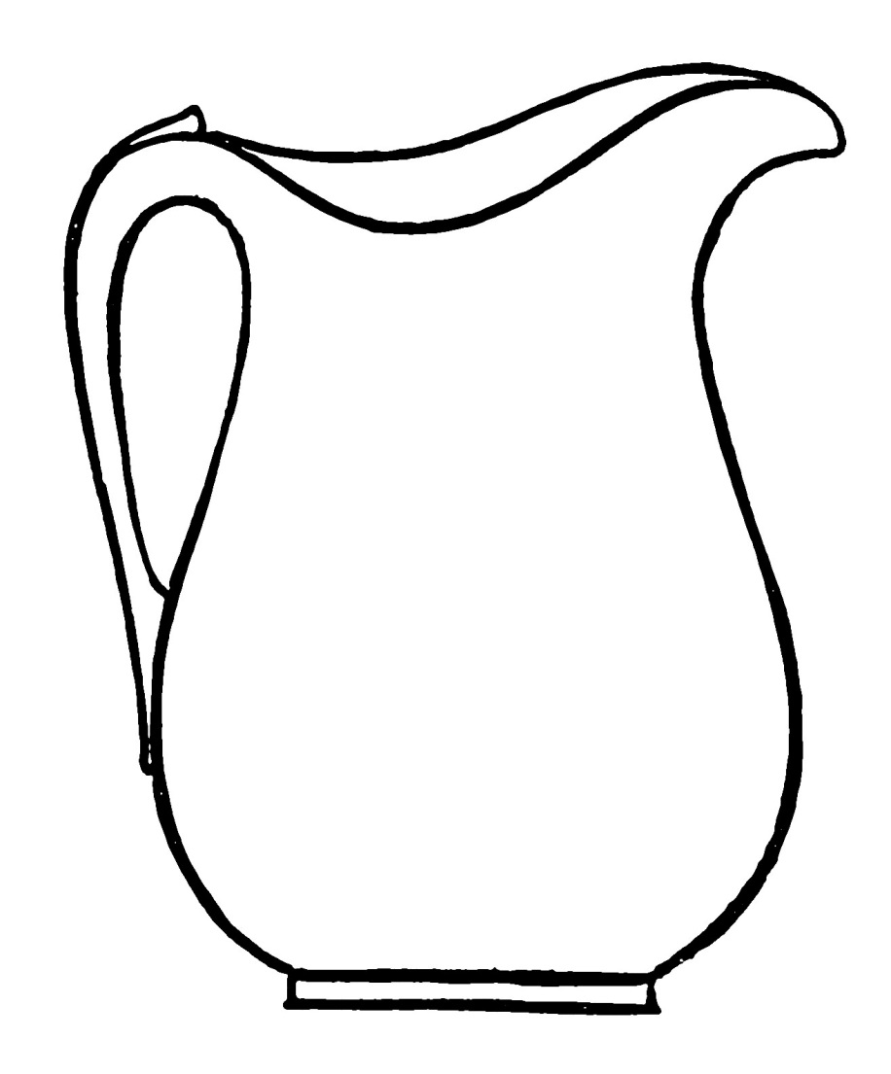
My Home Reader

Zug the Bug
Zug fell in the jug.
Oh no! Poor Zug.

