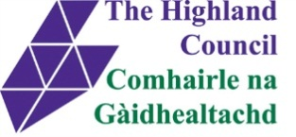
Spelling Intervention - Level 1/2 Pack 1
Alphabet Soup

Spelling is a vital component of reading. For young children spelling supports learning to read, and for older children, the meaningful relationships between words will contribute to vocabulary growth and reading comprehension. Spelling is an essential and complex skill involving multiple components, including visual memory, phoneme-grapheme awareness, as well as, orthographic and morphophonemic knowledge. Although spelling is important, it is often an activity which some pupils find boring or perplexing.

I explore sounds, letters and words, discovering how they work together, and I can use what I learn to help as I read and write ENG 0-12a/ LIT 0-13a/ LIT 0-21a

I enjoy exploring and playing with the patterns and sounds of language and can use what I learn.
LIT0-01a/LIT 0-11a/LIT0-20a
I can use my knowledge of sight vocabulary, phonics, context clues, punctuation and grammar to read with understanding and expression.
ENG 1-12a

I am learning to select and use strategies and resources before I read, and as I read, to help make the meaning of texts clear.
LIT 1-13a
I can select and use a range of strategies and resources before I read, and as I read, to make meaning clear and give reasons for my selection.
LIT 2-13a

Through developing my knowledge of context clues, punctuation, grammar and layout, I can read unfamiliar texts with increasing fluency, understanding and expression.
ENG 2-12a / ENG 3-12a / ENG 4-12a

Elements of Teaching Spelling
Most successful learning experiences for reading and spelling use a combination of sensory activities. When teaching spelling and reading try to include as many of the following as possible:
Pupil:
- hears it and sees it
- sounds it out looking at phonic patterns, syllables, chunks etc
- says it out loud
- says it silently
- reads it out of context
- reads it in context
- writes it out of context
- writes in in context
- writes it from memory
- makes connection with prior learning
- assesses his own work
- progressed monitored by instructor.
As instructors (class teachers, ASN teachers, PSAs, parents) we must provide certain conditions for learning.
Minimal distractions (both visual and auditory)
Repetition – small and often over at least three days
Positive cloaking – Make the learning experience as positive as possible
Built in self-evaluation

Spelling Intervention Group work 1
2 mins | Warm up exercise | Comments to guide you on ways to make changes to suit the needs of your pupils in subsequent sessions.
5 mins | Re-build dictation sentence jigsaw from yesterday.  Paste it into book and read it several times and review any tricky word strategies.  Close book and write it.  Child then corrects dictation using the pasted in sentence.
10 mins | Introduce new spelling pattern and rule (if applicable).  Look in the alphabet soup cards for words which fit that pattern.  Pupils copy them into their book.  Pupils think of a sentence (or more depending on pupil’s abilities) using as many words with that spelling pattern and adult scribes it.  Pupils then copy it in their own handwriting onto a strip of card. They highlight or circle every example of the new spelling pattern.  Pupils read and re-read sentence until they read it fluently.  They then cut up the sentence into word chunks and put it into an envelope/container for working with next session.
5 mins | Use rhyming words containing new spelling pattern into one of these poem templates.  Recite the poem.
8 mins | Finish the session by reading a story to the pupils. Encourage them to point out words which contain the new spelling pattern for the day. Praise when they find them.
Notes:

Spelling Intervention Group Work 1 – record sheet
Date: | Instructor:
Group members present
Re-building sentence
Comment on how individuals coped.
Writing the dictation
Comment on how individuals coped.
New spelling pattern
Comments on how individuals coped with new spelling pattern.
Rhyming activity
Comment on how individuals coped.
What story did you read?
Comment on how individuals coped.
Notes:
Alphabet Soup 1
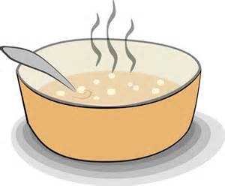
School soup hair soap

Mean boot coat chair hear

Ear pout found moon

Soon despair boat
around

oo, ou, ai, oa, ea
Alphabet Soup 2
Cooking stairs moat foam

Bean round zoom moan pair

Sound team food mail toad

found load zoo maid lean

paint

oo, ou, ai, oa, ea
Alphabet Soup 3
shop chip then why

where chalk wish path shoe

Thin chin white cash

Three . wheel wash

chart

Ch, sh, th, wh
Alphabet Soup 4
Mash arch with shrimp

whale march fish sharp

thick Path wheat cheat

shirt Crash whisper

think charts

Ch, sh, th, wh
Alphabet soup 5
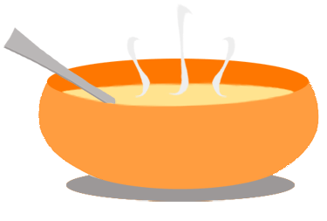

tray drop crayon prawn

crab proper draw trip

pray try cross dress

drip crash trash press

tr, dr, cr, pr
Alphabet soup 6
trust crust proud dream

dry cry draw prompt

true present cress trust

dream drill pram truck

crisps

tr, dr, cr, pr
Alphabet soup 7
scrap strip steam spend

slide scab spin slip

scarf stop start spot

spell stem slip sling

Sc, st, sp, sl

Alphabet soup 8
scone scramble star spill

spit scum still slope

sleep score spark steep

spam slack slap stick

scar

Sc, st, sp, sl

Alphabet soup 9
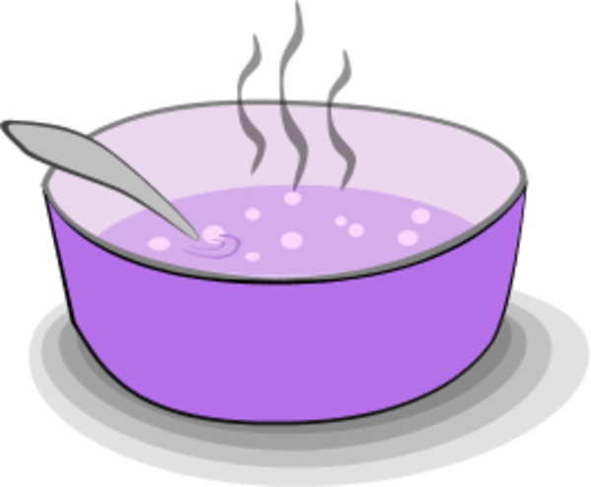
cone pine cube cane

rake time use phone

prune hate ride hope

shine home
rude fine plate

a-e, i-e, o-e, u-e
Alphabet soup 10
time chose name tube

tune frame grime bone

rope tape mine dupe

flute dive
hope tame nine

a-e, i-e, o-e, u-e
Alphabet soup 11
sigh time my shy

Tight fight buy try

light guy mine twine

cry fine fright kind

blind find tight fry

igh, y, i-e, uy, i
Alphabet soul 12
delight spite rice bight trike

spy died fly untie

might flight high fried

might polite ride

mind spicy dice

Igh, y, i-e, ie, i

Poetry Templates for Rhyming words
I like

I like _____________

And I like ______________

I like other things too!

I like _____________

And I like ______________

And I want to know about you!

I can see

I can see _____________

And ______________ too!

I can see ______________

How about you?

Where?

Where is the ______________

Where is the ______________

And where is the ______________

It’s in the ______________.

I’m looking

I’m looking for a _____________

And I’m looking for a ____________

And I really want a ____________

But a ___________ will do!

I’m looking for a ______________

And I’m looking for a ____________

But I really want a _____________

So I can give it to you!

