Spelling Intervention - Level 1 and 2 Pack 4
Based on Words Their Way
For more information research Words Their Way
(Also check internet for more resources)
Spelling is a vital component of reading. For young children spelling supports learning to read, and for older children, the meaningful relationships between words will contribute to vocabulary growth and reading comprehension. Spelling is an essential and complex skill involving multiple components, including visual memory, phoneme-grapheme awareness, as well as, orthographic and morphophonemic knowledge. Although spelling is important, it is often an activity which some pupils find boring or perplexing.
It is important that spelling is not pitched at the wrong level and success is built into the activity. Repetition is important and this can often be done through games and activities. It is important the pupils are actively engaged in the activities and not left to be passive participants.

I explore sounds, letters and words, discovering how they work together, and I can use what I learn to help as I read and write ENG 0-12a/ LIT 0-13a/ LIT 0-21a

I enjoy exploring and playing with the patterns and sounds of language and can use what I learn.
LIT0-01a/LIT 0-11a/LIT0-20a
I can use my knowledge of sight vocabulary, phonics, context clues, punctuation and grammar to read with understanding and expression.
ENG 1-12a

I am learning to select and use strategies and resources before I read, and as I read, to help make the meaning of texts clear.
LIT 1-13a
I can select and use a range of strategies and resources before I read, and as I read, to make meaning clear and give reasons for my selection.
LIT 2-13a

Through developing my knowledge of context clues, punctuation, grammar and layout, I can read unfamiliar texts with increasing fluency, understanding and expression.
ENG 2-12a / ENG 3-12a / ENG 4-12a

Elements of Teaching Spelling
Most successful learning experiences for reading and spelling use a combination of sensory activities. When teaching spelling and reading try to include as many of the following as possible:
Pupil:
- hears it and sees it
- sounds it out looking at phonic patterns, syllables, chunks etc
- says it out loud
- says it silently
- reads it out of context
- reads it in context
- writes it out of context
- writes in in context
- writes it from memory
- makes connections with prior learning
- assesses his own work
- progressed monitored by instructor.
As instructors (class teachers, ASN teachers, PSAs, parents) we must provide certain conditions for learning.
Minimal distractions (both visual and auditory)
Repetition – small and often over at least three days
Positive cloaking – Make the learning experience as positive as possible
Built in self-evaluation

Spelling Intervention Group work 4
5 mins | Warm up exercise – who has cards | Comments to help you adjust programme for subsequent sessions.
5 mins | Take sorting cards and ask the children to sort them into groups of common grapheme patterns. Do not tell them what the categories are. Let them explore the words to see what phonic patterns are there. (either use list of words from last session or take a new pack)
2 mins | Read the words to the teacher
5 mins | Write the words into your spelling journal in the correct categories.
10 mins | Do a word hunt. Look through a book or magazine for other words which can fit into each category.
5 mins | Do a blind sport. Work with a partner. One person choose ten words. He reads to the other person who tries to write them down. They check and correct then swap roles.
Notes:

Spelling Intervention Group Work 4 – record sheet
Date: | Instructor:
Group members

Warm up exercise – who has cards | How did they manage?
Sorting cards | How did each group member cope?
Read the words to the teacher | How did each group member cope?
Copy and write words | How did each group member cope?
Word hunt | How did each group member cope?
Blind sort | How did each group member cope?
Notes:
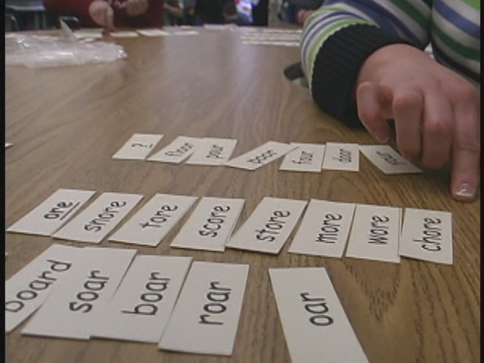
How to Do a Word Sort
Adapted from: Words their way
- Take out your cards.

- Read all of your cards.

- Ask a question if you don't know a word.

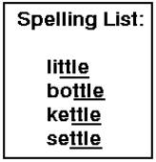
- Think about the sounds and spelling.

- Sort the words into columns.

- Read the words aloud to check.

- Ask the teacher to check.

- Write the words in your notebook in columns.

- Record your sort on your progress chart in your folder.

- Put your cards back in the envelope.

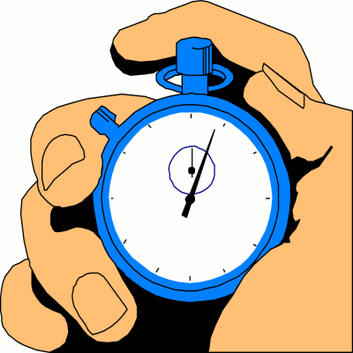
How to Do a Speed Sort
Adapted from: Words their way

- Take out your cards.

- Shuffle the cards.

- Get your watch ready. Set it to zero.

- Press start and begin sorting your cards.

- When you finish sorting, press stop.

- Record your time on your progress chart.

- Try again to see if you can get a better time.

- Record your new time and calculate the difference.

- Share the results with a teacher.

- Put your cards back in the envelope.

How to Do a Blind Sort
Adapted from: Words their way
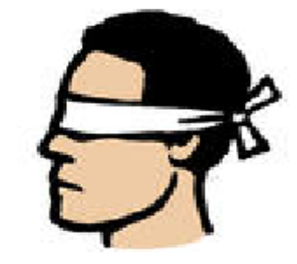
- Find a partner.

- Open to a new page in your journal.

- Write the head words for your categories.

- Ask your partner to select 10 or 12 words.

- Then ask your partner to read the words aloud.

- When he or she reads the word, you write it in the correct category.

- When you finish, check the words for correct spelling and category.

- Show a teacher and record the results on your progress chart.

- Thank your partner and offer to read his/her words.

- Put your cards in the envelope.

How to Do a Word Hunt

Adapted from: Words their way

- Decide if you are going to work alone or with a partner.

- Take out your cards.

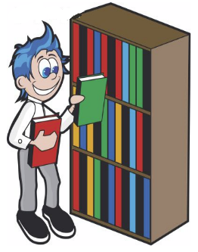
- Sort and review your words.

- Find a book or a magazine to read.

- In your journal, write the title of the book.

- Read the book and look for any words that fit your categories.

- Record the words in your journal.

- Write the number of words you found on your progress chart.

- Show a teacher.
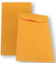
- Then put your cards in the envelope.

Spelling journal

Phonic pattern
Notes:
oo |  |  | u_e
ue |  |  | ew
ou |  |  | oe

f |  | Flip book  Cut out small cards and staple them onto this section along the left edge. This creates a book where each page adds a different starting phoneme to add to the final phonic pattern . |  |  | oot
b |  |  | r |  |  | w |  | sh
f |  | Flip book  Cut out small cards and staple them onto this section along the left edge. This creates a book where each page adds a different starting phoneme to add to the final phonic pattern . |  |  | ew
c |  |  | gr |  |  | st |  | fl
bl |  | Flip book  Cut out small cards and staple them onto this section along the left edge. This creates a book where each page adds a different starting phoneme to add to the final phonic pattern . |  |  | ue
gl |  |  | c |  |  | h |  | tr
t |  | Flip book  Cut out small cards and staple them onto this section along the left edge. This creates a book where each page adds a different starting phoneme to add to the final phonic pattern . |  |  | une
pr |  |  | J |  |  | d |  | r
book | boot |  |  | food |  |  | wood |  | moon
cute | tune |  |  | flume |  |  | prune
glue | blue |  |  | cue |  |  | true |  | hue
stew | chew |  |  | grew |  |  | flew |  | few
shoe | soup |  |  | youth

Chew your food a few times.
My shoe got stuck in wood glue.
Soon a few blue flowers grew.

oa | o_e
ough | ow

c |  |  |  |  |  | Flip book  Cut out small cards and staple them onto this section along the left edge. This creates a book where each page adds a different starting phoneme to add to the final phonic pattern . |  |  |  |  |  |  |  | oat
b |  |  |  |  |  |  | m |  |  |  |  |  |  | st
sh |  |  |  |  |  | Flip book  Cut out small cards and staple them onto this section along the left edge. This creates a book where each page adds a different starting phoneme to add to the final phonic pattern . |  |  |  |  |  |  |  | ow
b |  |  |  |  |  |  | m |  |  |  |  |  |  | fl |  |  |  |  | gr
c |  |  |  |  |  | Flip book  Cut out small cards and staple them onto this section along the left edge. This creates a book where each page adds a different starting phoneme to add to the final phonic pattern . |  |  |  |  |  |  |  |  | one
b |  |  |  |  |  |  | p |  |  |  |  |  |  | t |  |  |  |  | st
oat |  |  |  | coat |  |  |  |  |  |  |  | boat |  |  |  |  | foam |  |  |  |  | roam
home |  |  |  | bone |  |  |  |  |  |  |  | cone |  |  |  |  | hope |  |  |  |  | code
snow |  |  |  | bow |  |  |  |  |  |  |  | show |  |  |  |  | low |  |  |  |  | grow
toe |  |  |  |  |  |  |  |  |  |  |  | though
My boat home sat in the foam.
I hope the snow will land on my toe.
How slow do our bones grow?
Can you show the code for the boat?
oi |  |  |  |  |  |  |  |  |  |  |  |  | oy
b |  |  |  |  |  |  |  | Flip book  Cut out small cards and staple them onto this section along the left edge. This creates a book where each page adds a different starting phoneme to add to the final phonic pattern . |  |  |  |  | oil
s |  |  |  |  |  |  | t |  |  |  |  |  |  | f |  |  |  |  | c
b |  |  |  |  |  |  |  | Flip book  Cut out small cards and staple them onto this section along the left edge. This creates a book where each page adds a different starting phoneme to add to the final phonic pattern . |  |  |  |  | oy
j |  |  |  |  |  |  | t |  |  |  |  |  |  | pl
oil | boil |  |  |  |  |  |  |  |  |  | coin |  |  |  |  |  |  | join |  | choice
boy | toy |  |  |  |  |  |  |  |  |  | employ |  |  |  |  |  |  | joy
I have a coin to pay for my choice of toy.
I joined the boy to boil the water.
ai |  |  |  |  |  |  |  |  |  |  |  |  | ay
a_e |  |  |  |  |  |  |  |  |  |  |  |  | ae
h |  |  |  |  |  |  |  | Flip book  Cut out small cards and staple them onto this section along the left edge. This creates a book where each page adds a different starting phoneme to add to the final phonic pattern . |  |  |  |  | air
st |  |  |  |  |  |  | f |  |  |  |  |  |  | fl |  |  |  |  | ch
h |  |  |  |  |  |  |  | Flip book  Cut out small cards and staple them onto this section along the left edge. This creates a book where each page adds a different starting phoneme to add to the final phonic pattern . |  |  |  |  | ay
st |  |  |  |  |  |  | m |  |  |  |  |  |  | p |  |  |  |  | tr
h |  |  |  |  |  |  |  | Flip book  Cut out small cards and staple them onto this section along the left edge. This creates a book where each page adds a different starting phoneme to add to the final phonic pattern . |  |  |  |  | ate
st |  |  |  |  |  |  | pl |  |  |  |  |  |  | m |  |  |  |  | d
p |  |  |  |  |  |  |  | Flip book  Cut out small cards and staple them onto this section along the left edge. This creates a book where each page adds a different starting phoneme to add to the final phonic pattern . |  |  |  |  | ear
t |  |  |  |  |  |  | b
hair |  |  | chain |  |  |  |  |  |  | hail |  |  |  |  |  | sail
hate |  |  | plate |  |  |  |  |  |  | same |  |  |  |  |  | made |  |  |  |  |  |  | cape
tray |  |  | may |  |  |  |  |  |  | stay |  |  |  |  |  | play |  |  |  |  |  |  | day
bear |  |  | tear |  |  |  |  |  |  | pear |  |  |  |  |  | where |  |  |  |  |  |  | there
The pear is on the plate on the tray.
Where shall the bear play today?
Her hair was made a long cape.
The hail storm made a tear in the ship’s sail.
ea |  |  |  |  |  |  |  |  |  |  |  |  | ee
e |  |  |  |  |  |  |  |  |  |  |  |  | ie
h |  |  |  |  |  |  |  | Flip book  Cut out small cards and staple them onto this section along the left edge. This creates a book where each page adds a different starting phoneme to add to the final phonic pattern . |  |  |  |  | ear
g |  |  |  |  |  |  | f |  |  |  |  |  |  | sh |  |  |  |  | n
h |  |  |  |  | Flip book  Cut out small cards and staple them onto this section along the left edge. This creates a book where each page adds a different starting phoneme to add to the final phonic pattern . |  |  |  |  |  |  |  | ear
g |  |  |  |  |  |  | f |  |  |  |  |  |  | sh |  |  |  |  | n
ch |  |  |  |  |  |  |  | Flip book  Cut out small cards and staple them onto this section along the left edge. This creates a book where each page adds a different starting phoneme to add to the final phonic pattern . |  |  |  |  | ief
th |  |  |  |  |  |  | br |  |  |  |  |  |  | gr
h |  |  |  |  |  |  |  | Flip book  Cut out small cards and staple them onto this section along the left edge. This creates a book where each page adds a different starting phoneme to add to the final phonic pattern . |  |  |  |  | eep
m |  |  |  |  |  |  | k |  |  |  |  |  |  | sh |  |  |  |  | d
ear |  | hear |  |  |  |  |  |  | team |  |  |  |  |  |  | heat |  |  |  |  | mean
keep |  | meet |  |  |  |  |  |  | been |  |  |  |  |  |  | deep |  |  |  |  | teeth
here |  |  |  |  |  |  |  |  | me |  |  |  |  |  |  | we |  |  |  |  | be
pier |  | piece |  |  |  |  |  |  | thief |  |  |  |  |  |  | chief
With my ears I hear things here and there.
The team’s chief found the mean thief.
I eat a piece of meat with my teeth.
Meet me to heat the meat before we eat it.

y |  |  |  |  | ie
igh |  |  |  |  | i_e
m |  |  | Flip book  Cut out small cards and staple them onto this section along the left edge. This creates a book where each page adds a different starting phoneme to add to the final phonic pattern . |  | y
tr |  |  | sk |  |  | fl |  | b
h |  |  | Flip book  Cut out small cards and staple them onto this section along the left edge. This creates a book where each page adds a different starting phoneme to add to the final phonic pattern . |  | ight
s |  |  | f |  |  | fl |  | br
fl |  |  | Flip book  Cut out small cards and staple them onto this section along the left edge. This creates a book where each page adds a different starting phoneme to add to the final phonic pattern . |  | ies
p |  |  | tr |  |  | fr |  | sp
m |  |  | Flip book  Cut out small cards and staple them onto this section along the left edge. This creates a book where each page adds a different starting phoneme to add to the final phonic pattern . |  | ine
n |  |  | f |  |  | sh |  | p
sky | by |  |  | try |  |  | my
pie | tie |  |  | skies |  |  | fries
high | tight |  |  | fight |  |  | light
time | pride |  |  | nice |  |  | pine |  |  | mine
At night the moon lights up the sky.
I don’t like my pie and fries.
What time is the sun high in the sky?
My tie is too tight.
of | often |  |  | after |  |  | elf |  |  | farm
cough | rough |  |  | laugh
photo | phone |  |  | elephant
stuff | cuff |  |  | cliff |  |  | staff
I cough when I laugh at funny jokes.
Do you like funny laughter on the phone?
Are you full after you have had enough to eat?
Please cover your mouth before you cough.
jug | jump |  |  | jelly |  |  | jog
rage | cage |  |  | huge
nudge |  | ridge |  |  | badge |  |  |  | fridge

I found a huge jelly in the fridge.
I jump and jog along the ridge.
Jack nudged me to get the badge.
Is the jug in the fridge?
nit |  | name |  |  | pan |  | shine |  |  |  | tune
gnat |  | gnome |  |  |  | gnarl |  |  |  |  | gnaw
knit |  | knew |  |  | knight |  |  |  | know
runner |  |  | winner |  |  |  | inn
The knight knew the gnome’s name.
Do you know how to knit a nice mat?
I know the runner who was the winner.
The gnat’s knees were gnarled.
sit | star |  |  | sit |  |  |  | pens |  | stand
hiss | pass |  |  | grass |  |  |  | kiss |  | moss
circle | city |  |  | cite |  |  |  | cist
science |  |  | ancient |  |  |  | scent |  |  |  | cent
In the city I sit on the grass.
I drew a circle around the star.
Pass the pens around the circle.
The scent of the grass was nice.

