
Spelling Intervention Pack 6
Level 2 and 3
Suffixes and Prefixes
Being an active learner rather than a passive one, helps the child to develop a thought out understanding of phonics and to be able to assess his own work and thus know how to correct and retain the information learned.
A multisensory approach provides learning that can be particularly helpful for children with learning and attention issues. For example, these kids may have trouble with visual or auditory processing. That can make it hard for them to learn information through only reading or listening.
Using multiple sensory activities gives us more ways to connect with what we are learning. This type of hands-on learning can make it easier for pupils to:
- Collect information
- Make connections between new information and what they already know
- Understand and work through problems
- Use nonverbal problem-solving skills
Multisensory instruction helps kids tap into their learning strengths to make connections and form memories.
CompuRead and Write is an activity which keeps the pupils actively involved throughout the whole session, using a variety of skills and sensory experiences.

I can use my knowledge of sight vocabulary, phonics, context clues, punctuation and grammar to read with understanding and expression. ENG 1-12a

I am learning to select and use strategies and resources before I read, and as I read, to help make the meaning of texts clear. LIT 1-13a
I can select and use a range of strategies and resources before I read, and as I read, to make meaning clear and give reasons for my selection. LIT 2-13a

Through developing my knowledge of context clues, punctuation, grammar

Elements of Teaching Spelling
Most successful learning experiences for reading and spelling use a combination of sensory activities. When teaching spelling and reading try to include as many of the following as possible:
Pupil:
- hears it and sees it
- sounds it out looking at phonic patterns, syllables, chunks etc
- says it out loud
- says it silently
- reads it out of context
- reads it in context
- writes it out of context
- writes in in context
- writes it from memory
- makes connections with prior learning
- assesses his own work
- progressed monitored by instructor.
As instructors (class teachers, ASN teachers, PSAs, parents) we must provide certain conditions for learning.
Minimal distractions (both visual and auditory)
Repetition – small and often over at least three days
Positive cloaking – Make the learning experience as positive as possible
Built in self-evaluation

Spelling Intervention Group work 2
2 mins | Revise treasure chest cards if doing this for a second or subsequent time. | Comments to inform changes to meet the need of your pupils in subsequent lessons
3 mins | Talk about prefixes and suffixes and how we can look at longer words to see if we can find any prefixes, suffixes and the root word.  Explain how this can make spelling easier especially if we already know how to work out the spelling for the root word.  Show how il+logic beans there is now a double ll. Double letters often cause confusion. The prefix does not alter the root word.
2 mins | Second and subsequent sessions revise the above lesson briefly then ask children to take out their cut up words from last session and rebuild them. These could be stuck into their jotters and copied.
2 mins | Place the cut out prefixes, roots and suffixes on the table. Ask the children to try to create words. This could be:  Prefix + root  Root + suffix  Prefix + rot + suffix
2 mins | Ask the children to read the words which they have made, then write them down on strips of card. These can be cut into prefix, root and suffix sections and kept for next session.
2 mins | Give the children five treasure chest cards and go over the meanings of the suffixes and prefixes. Each new session, give children a further three to five cards.
5 mins | Read one of the dictation cards several times talking about the words.  Hide the card and ask the children to write it. They then check their own work, ticking each correct word and underlining and changing any mistakes.
8 mins | If time play:  ‘I have, who has’ cards,  Search for prefixes and suffixes in a book  OR  Racing round board game
Notes:

Spelling Intervention Group Work 2 – record sheet
Date: | Instructor:
Group members present
How securely has each group member remembered the words from last session?
How has each group membered managed to match up prefixes, suffixes and roots to create new words?
How has each group member managed the dictation cards?
How has each group member managed with the game?
Notes:
‘I have, You has…’ cards
I have  happy  Who has  unhappy? |  |  |  | I have  unhappy  Who has  care? |  |  |  | I have  care  Who has  careless?
I have  careless  Who has  reason? |  |  |  | I have  reason  Who has  reasonable? |  |  |  | I have  reasonable  Who has  open?
I have  open  Who has  unopened? |  |  |  | I have  unopened  Who has  agree? |  |  |  | I have  agree  Who has  disagreed?
I have  disagreed  Who has  view? |  |  |  | I have  view  Who has  review? |  |  |  | I have  review  Who has  happy?
Start | 1 | 2 | 3 |  | 4 | 5 | 6 |  | 7 | 8 | 9
55 | Instructions:  Print two of each card  Each player has a counter. In turn each player throws the dice and moves on by that number.  If they land on a coloured square, they take a card from that pack.  If they land on a white square they can swap one of their cards with another player.  They must try to make words using, the root, suffix and prefix cards.  The winner is the person who has made the highest score once all cards have been collected. 2 points for a two part word and 3 points for a three part word.  Racing Around with suffixes and prefixes
54
53
52
51
50
49
48
47 | 46 | 45 | 44 |  | 43 | 42 | 41 |  | 40 | 39 | 38
10 | 11 | 12 | 13 |  | 14 | 15 | 16 |  | 17 | 18 | 19
 |  |  |  |  |  |  |  |  |  |  | 20
 |  |  |  |  |  |  |  |  |  |  | 21
 |  |  |  |  |  |  |  |  |  |  | 22
 |  |  |  |  |  |  |  |  |  |  | 23
 |  |  |  |  |  |  |  |  |  |  | 24
 |  |  |  |  |  |  |  |  |  |  | 25
 |  |  |  |  |  |  |  |  |  |  | 26
 |  |  |  |  |  |  |  |  |  |  | 27
37 | 36 | 35 | 34 |  | 33 | 32 | 31 |  | 30 | 29 | 28

un | re
dis | pre
mis | de
sub | il
co | anti
happy | use
appear | order
take | stress
marine | logical
writer | freeze
wish | good
wash | join
sing | rent
care | enjoy
invent | bad
ness | ful
able | er
ing | al
ment | less
or | ly

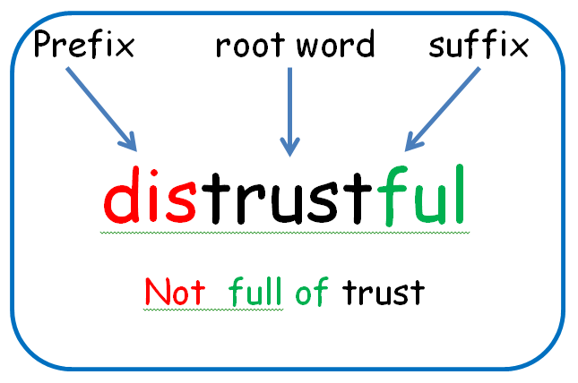
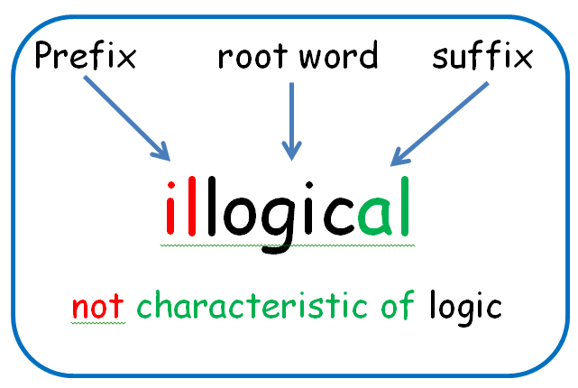
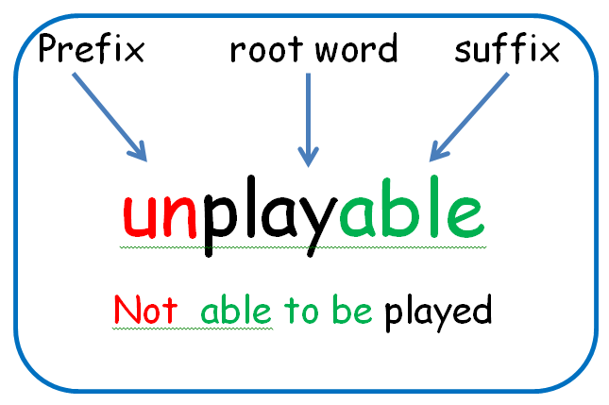

I am happy with my present.

I am unhappy with my present.
He wrote his work in a careless way.

He wrote his work in a careful way.
Dad defrosted the chicken for dinner.

Dad put frosting on the birthday cake.

Table sort cards
un | anti |  | dis |  | sub
re | auto |  | de |  | pre
mis | co |  | ex |  | il
ness | able |  | er |  | ed
ing | ful |  | aly |  | al
ly | y |  | ment |  | or
d | ion |  | less
cover |  | like |  | agree
logic |  | order |  | expect
act |  | luck |  | trust
connect |  | predict |  | proper
success |  | equal |  | reason
new |  | honour |  | part
legal |  | write |  | play
tie |  | agree |  | read
joy |  | view |  | obey
prove |  | happy |  | even
less |  | heart |  | heat
build |  | call |  | wrinkle
freeze |  | able |  | worker

Treasure chest of prefies and sufixes
re | again, back
un | not
dis | not
pre | before
anti | against
sub | under
auto | on its own
de | away  opposite
mis | bad or wrong
co | together
ex | no longer
il | not
-able | can be done
-ful | full of
-nes | state or condition
-less | without
-ment | action or process
-er/ -or | one who
-ed/-d | past tense
-ing | present tense verb
-ly/ -al/ -aly | characteristic of
-ion | act or process
-y | characterised by

