First
First
Next
First

The ‘First’ ‘Next’ structure can be used alongside visuals to develop the terms when sharing texts or creating texts using ‘Who?’ ‘Where?’ ‘When?’ ‘What happened?’.

First
First
Then
First

The ‘First’ ‘Then’ structure can be used as an alternative to ‘First’ ‘Next’ alongside visuals to develop the terms when sharing texts or creating texts using ‘Who?’ ‘Where?’ ‘When?’ ‘What happened?’.

First
Last/ Finally
First
Next

The ‘First’ ‘Next’ ‘Last/ Finally’ structure can be used alongside visuals to develop the terms when sharing texts or creating texts using ‘Who?’ ‘Where?’ ‘When?’ ‘What happened?’.

Last/ Finally
Then
Next
First

The ‘First’ ‘Next’ ‘Then’ ’Last/ Finally’ structure can be used alongside visuals to develop the terms when sharing texts or creating texts using ‘Who?’ ‘Where?’ ‘When?’ ‘What happened?’.

Last/ Finally
After that
Then
Next
First

The ‘First’ ‘Next’ ‘Then’ ‘After that’ ’Last/ Finally’ structure can be used alongside visuals to develop the terms when sharing texts or creating texts using ‘Who?’ ‘Where?’ ‘When?’ ‘What happened?’.

Who? | Where? |  | When?
What happened?
Problem/ Event/ Scenario |  | Solution/ End

The narrative and sequencing concept grid can be used to plan texts using the narrative and sequencing concepts. (colour)

Who? | Where? |  | When?
What happened?
Problem/ Event/ Scenario |  | Solution/ End

The narrative and sequencing concept grid can be used to plan texts using the narrative and sequencing concepts. (black and white)

Who? | Where? |  | When?
Descriptive language: | Descriptive language: |  | Descriptive language:
What happened?
Problem/ Event/ Scenario |  | Solution/ End

The narrative and sequencing concept grid, with descriptive language linked to ‘Who’, ‘Where’ and ‘When’, can be used to plan texts using the narrative and sequencing concepts. (colour)

Who? | Where? |  | When?
Descriptive language: | Descriptive language: |  | Descriptive language:
What happened?
Problem/ Event/ Scenario |  | Solution/ End

The narrative and sequencing concept grid, with descriptive language linked to ‘Who’, ‘Where’ and ‘When’, can be used to plan texts using the narrative and sequencing concepts. (black and white)

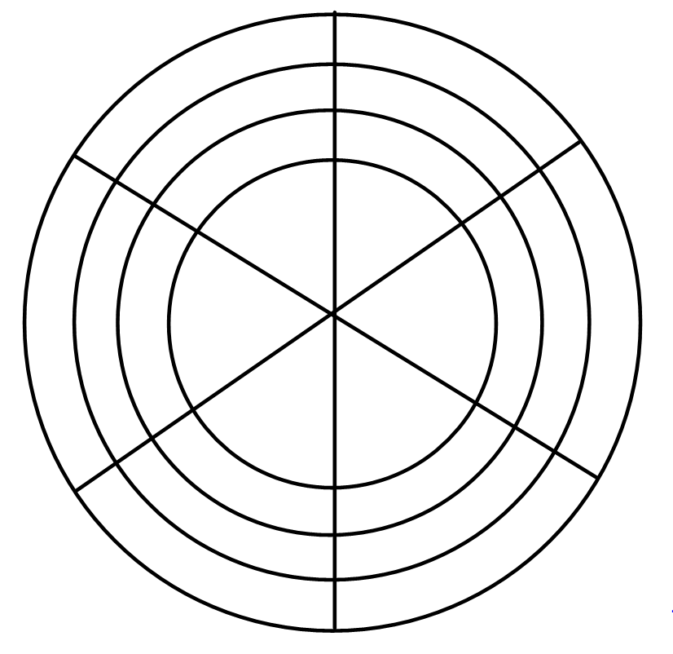

This template can be used to as a plan for descriptive language when developing the narrative and sequencing concepts.
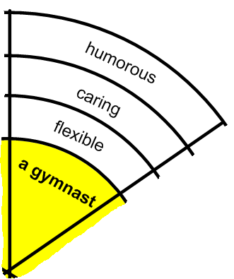
e.g. When developing the narrative concept of ‘Who’, children place the names of their characters (the who) in the inner segments. In the outer segments they then use vocabulary to describe the character. This could be used to analyse characters in a text which they have read, or to describe characters which they have created. This could be used for the concept of describing the ‘Where’, ‘When’ and the ‘What happened’.

