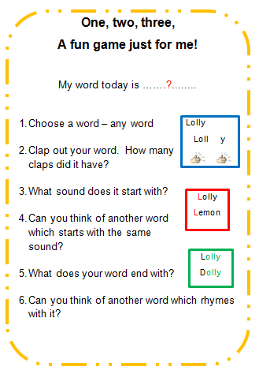 |  | Spelling with our Children  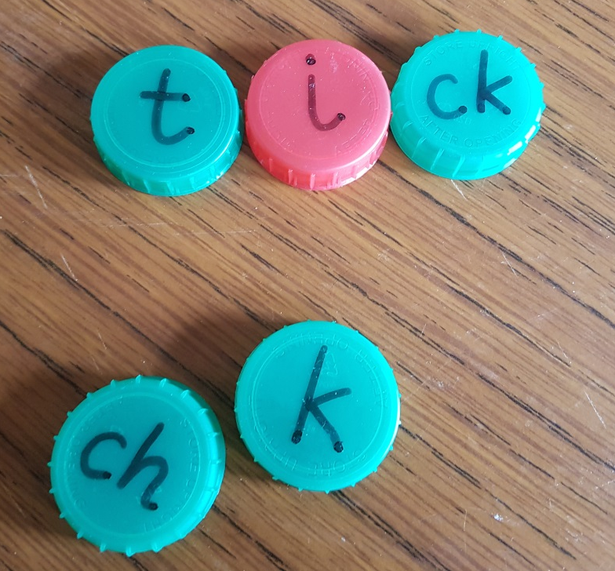
How to help our children with spelling  Our children often want to start writing before understand the relationship between sounds and letters. Many children are desperate to learn to write their names, whilst others are not ready. Before a child enters school, they should not be under any pressure to write, but we should demonstrate the value of reading and writing.  Talk to your child about sounds. Teach them nursery rhymes and songs and have fun with silly rhymes and games. The more they hear sounds and know how they work, the easier spelling will be.  Once your child is interested in words and sounds, choose some short words and stretch them so that your child can hear all of the sounds in the word and ask your child to copy you.  Make sure that you use the letter sounds and not the letter names.  cat c – a – t  dog d – o – g  chicken ch – i – ck – en  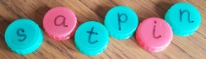  You can write sounds on bottle tops and show your child how to give each sound a letter. |  | Once they know how the sounds are represented by which letter then if your child wants to learn how to write a word follow this pattern.  - How do I write sister?  - Let’s stretch the word so that we can hear all of the sounds. s – i – s – t – e – r  - Count the number of sounds that you hear.  s – i – s – t – e – r (6 sounds)  - This is how we write s – i – s – t – e – r  - Let’s read it. s – i – s – t – e – r = sister.  - How do I write brother?  - Let’s stretch the word so that we can hear all of the sounds. b – r – o – th – e – r  - Count the number of sounds that you hear.  b – r – o – th – e – r (6 sounds)  - This is how we write b – r – o – th – e – r  - Let’s read it. b – r – o – th – e – r = brother.
  Close friends  Two or more letters which together make one sound.  (digraphs) | ch, sh, wh, oo, ea, igh, ow, ai
  Distant friends  Two letters which together make one sound but are separated by another letter.  (digraphs) | ate, ape, hide, hope, cube, here

