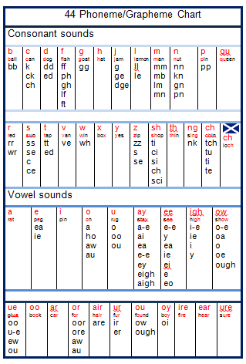 |  | Reading the  ‘Reading Book’  But he just won’t pay attention and try. If only he would try harder. What am I to do?  More than anything, I want my child to enjoy reading. I know that it is important and is good for him.  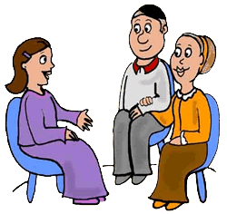  Don’t let reading become a battleground!
How can I get the most out of my child’s reading book?  When you read with your child…  - Make sure that distractions are at a minimum. E.g. Find a quiet place, turn off the TV and put away computers, phones and tablets.  - Talk with your child about the pictures in the book and about the story.  - Praise your child often while they are reading. When they self-correct a mistake or manage to read a difficult word.  - If your child is stuck at a word, wait for a few seconds, then show them how the word can be broken up into a series of codes. Read each code individually then altogether.  o ff i ci a l sh o pp i ng  Some sounds are written with codes of one letter, but other codes are made up of two or more letters.  sh, ch, igh, ea, ough, a-e, aigh, ng, the  - If your child makes a mistake, once you have helped them know how to decode the word, ask them to hunt for the word on the page.  - Practice is the key to good reading. The more you practice, the easier it will become.  - Encourage your child to read with expression. You model how to read with an expressive voice.  - Make this a happy time. You are setting the scene for their future reading habits. |  | What do we do when it all goes wrong?  From time to time reading can become a battle ground.  When it does, here are some questions to ask ourselves.  - Is reading still a special time?  - Are distractions still at a minimum?  - Does the child know that I am giving them all of my attention?  - Am I praising enough?  - Am I helping my child to work out words which they are stuck on without making them feel a failure?  - Am I chatting about how the story relates to the child’s own experiences?  - Am I expecting the child to read too much at one time? If so, you could read sentence about, word about or you read and every time you stop they have to jump in with the next word.  - Am I calmly explaining how to decode these difficult words?  