Reading is not only essential for many areas of learning but can be a means of escape from everyday life and an incredible journey into other places and times.  Reading with our Children  - Create reading rituals and read together every day.  - Make the reading time an enjoyable time.  - Talk about the pictures and ask questions.  - Share different kinds of books.  - Read with expression.  - Read favourite books again and again.  - Encourage your child to join in with rhymes and repeated phrases. |  | Reading to our Children  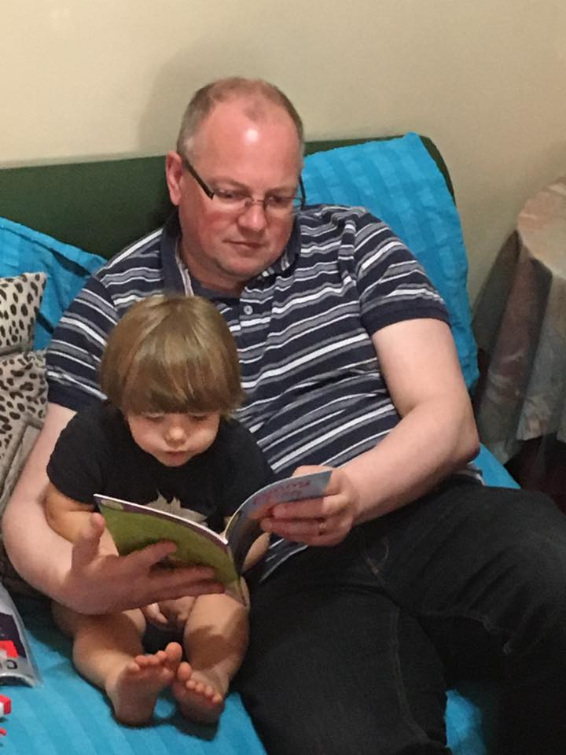  Investing in their future
Probably the most important activity that we can do with our children to prepare them for reading is to read with them often.  As we read to our children they learn the importance of language. They learn to love the sound of language and to realise that the marks on the page represent the sounds and words we speak.  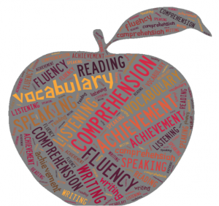  When we talk to our children, most of the words we use are ones that they know so that they understand what we are saying to them or asking them to do. Books tend to use a much larger vocabulary and if we read these stories to them over and over again, our children pick up a rich vocabulary. A large vocabulary provides a firm foundation for building communication skills, reading, comprehension and writing.  Even when children can read to themselves, it is good to continue to read to them. This means that they can stretch their learning beyond their reading levels. |  | As we read with them they learn:  - There is a difference between the words and the pictures.  - Words on the page have meaning, and that is what we learn to read.  - Words go across the page from left to right and top to bottom.  - Words on the page are made up of letters and are separated by spaces.  - Each letter has two forms: capital letters and lower case letters.  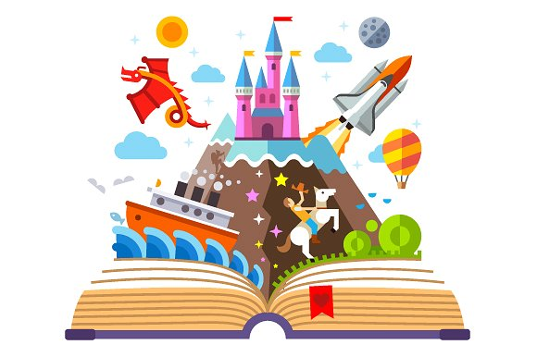  When we read to our children, it fuels their imagination. People who have not been read to, often find it difficult to write stories. When we listen to stories, we learn about how stories are shaped, how plots evolve and how we can use words to create emotion and understanding.

