Reading Challenges
We all know that reading is so important for our children and young people, not just for developing their literacy skills, but also for developing their thirst for knowledge and as a way to relax and escape from the rigors of life.

I’m sure that you all have strategies for doing this, but here are three challenges that you could use to encourage reading.
The Genre Pizza
Challenge 20/20 Upper school
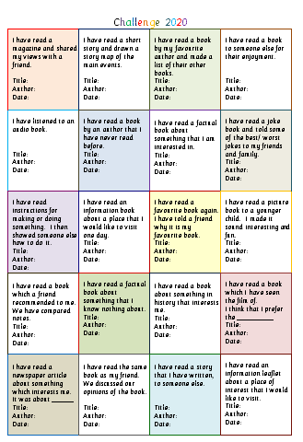
Challenge 20/20 Lower school
Around the World in 80 days
If you have created other challenges and are willing to share, please send them on to me.
Ideas for reading for enjoyment.

