Literacy – Broad and General
Time off school may sound like great fun – and it is, but we must use our time wisely and see it as an investment in our future.
This time gives you the opportunity to study what you need to learn in the way that you like learning. You can study in your bedroom or your kitchen. You can pace about while reciting facts or curl up on the couch to read a book.
There are some things that you should do every day. You can choose how you do them, but remember, wasting your time is NOT an investment in your future!
Keep a log of what you do each day. Jot down the time you spent on everything and what you studied or worked on. Remember to get some exercise too. This is really important.
In literacy each day:
- Read : read a chapter or more of a fiction book as well as texts to do with other subjects. If you run out of books to read, you can download books from these sites.
BBC Newsround
BBC Bitesize
Barnes and Noble Free ebooks
Manybooks

Each day, choose one piece of text that you have read and ask yourself some of the questions from this list. Heurisko Comprehension Questions You can answer the questions orally or you may wish to write them down. Remember to write in complete sentences and check that you have answered the question. 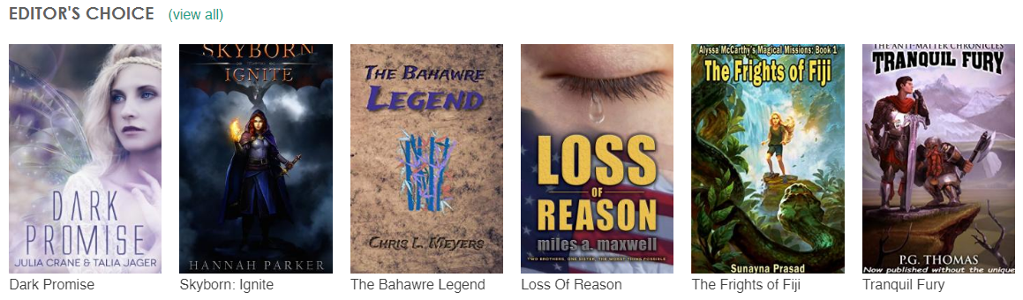
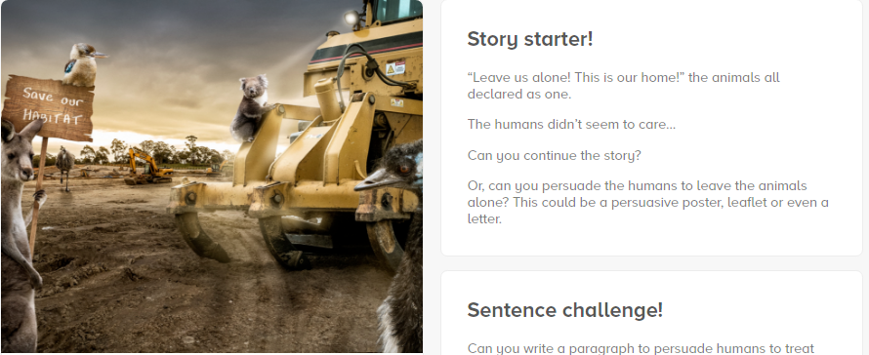
- Write: write every day. You can write stories, reports, poems, plays, posters… The list of possibilities is endless. You don’t need to write a long piece of work each day, but you should write. Don’t rush your writing. Read over it, edit and embellish it until you have a piece of work that you are proud of.
Pobble 365 will give you a different picture every day, ideas for story writing, questions to think about and a grammar task.
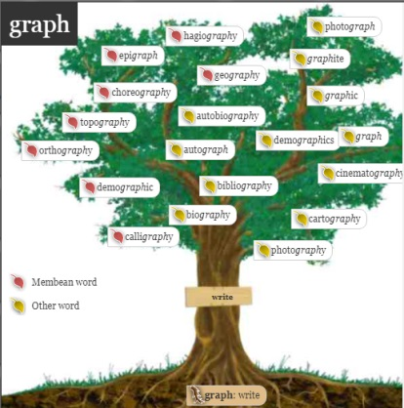
- Word Work: investigate words. Look at how words join together to make new words. For a daily word challenge click here. Two web pages that are interesting are: Membean Root Trees and Visuwords. These will help you understand the parts of individual words.
- Vocabulary: Sometimes we recognise words and may even be able to use them, but don’t really know their meaning. This will test your knowledge of grammatical terms. If you don’t really understand their meaning, click here. Don’t worry if you have never heard some of these terms. A lot of adult don’t know them either, but they are there for you if you like a challenge!
- Comprehension: think about what things mean. This could be, understanding something that you have read, or heard, or watched. You could use some of the Heurisko Cards to help you question texts for understanding.
It is also good to read a passage and answer given questions. To do that, go to Readtheory.org and sign in as a student. You will do a short placement test first.

- Talking and Listening: Try to spend time discussing things with someone else. You may want to discuss your favourite music, what you are hearing about on the news, or something else that you are interested in. Newsround
Remember to pace yourself, take short breaks and give yourself a realistic target for what you will do each day. Record what you do and how you feel each activity has gone. Remember to take some exercise, have down time when you need it and try to do something creative.
This is the time for you to become more independent.

