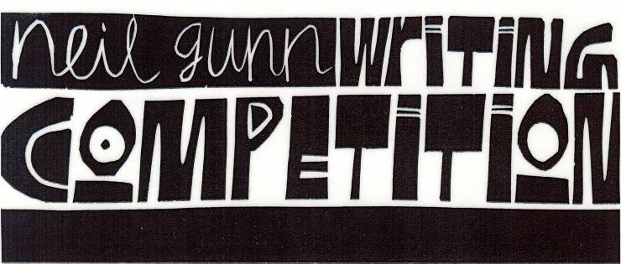

Organised by High Life Highland & The Neil Gunn Trust
Schools’ sections sponsored by The Lydia Michael Trust
Entry Form: Primary School (P5-P7)
Theme for 2021-2022
“It is a terrible thing to be bursting with a secret you can’t tell”
from Young Art and Old Hector by Neil Gunn
Please read the entry rules carefully and sign the Data Protection declaration before submitting your entry.

Title of piece

Name of entrant

Address (school or home)

School

Data Protection – The information you have supplied will be used for the purpose(s) for which you
have provided it. High Life Highland will also use it to plan improvements and to meet our obligations in
delivering services on behalf of The Highland Council. This data will be maintained in accordance with
the Data Protection Act 1998 and will not be passed on or sold to any other organisation without your
prior approval, unless there is a legal requirement to do so.
Declaration I agree to the use of my personal data as detailed above.
Signature (Parent/Guardian/Teacher)..........................................................Date ..................
