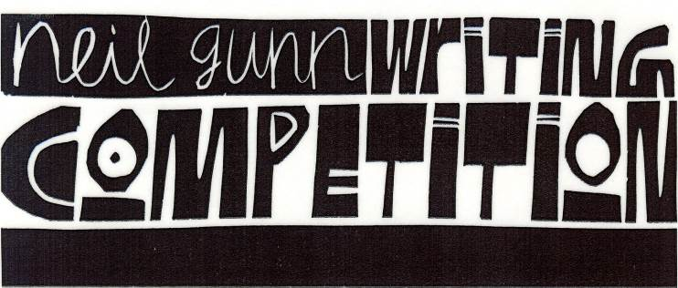

Organised by High Life Highland & The Neil Gunn Trust
Schools’ sections sponsored by The Lydia Michael Trust
2021-22 Competition Open Now!
Primary School P5-P7
Theme for 2021-2022

“It is a terrible thing to be bursting with a secret you can’t tell”

from Young Art and Old Hector by Neil Gunn
For full details please ask your teacher or librarian or visit www.highlifehighland.com/neilgunn
Closing date Friday 04 March 2022

