What do we do with a Pick and Mix Chart? Teacher Prompt
 | Group work
Day One | 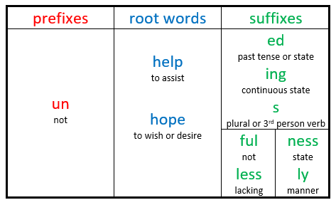  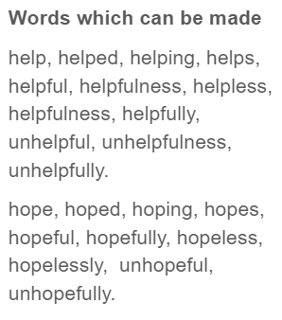  Look at your morpheme Pick and Mix for the week.  In your group, see how many words that you can make using different combinations of prefixes, suffixes and roots. Sometimes you may be able to use more than one prefix or suffix.  Chat with your group about the meaning of the different morphemes and how they have changed the meaning of the root word. Sometimes it is not obvious.
Day Two | 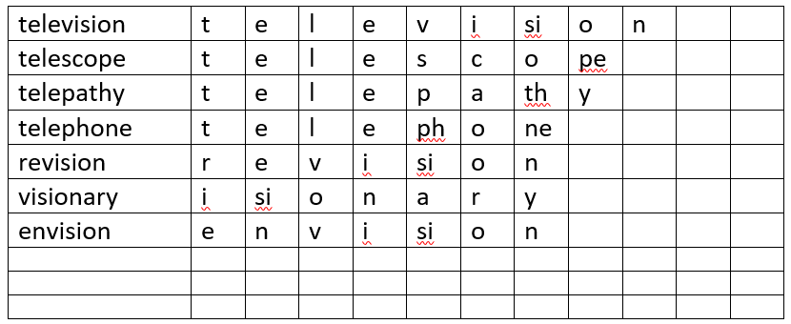  Say each of the words and count the sounds that you hear in the word.  Write each sound in a separate box on the soundbox chart. Sometimes a sound will be made up of more than one letter. E.g. ch, ng, igh, ph.  Compare your findings with each other.  Chat about what you think each of your words mean and how they are connected to the meaning of the morpheme that you know.
Day Three | In your group, create a sentence for each of the words. Together, check that the words in each sentence are spelled correctly, and have the correct punctuation.  Write each of the sentences in your book. If a sentence is short or simple, grow the sentence by asking the questions, why, what, where, when, or how.  E.g. I watched the television. Why?  I watched the television because I wanted to see the Olympic games.  Underline your spelling word using this colour code.  Noun; proper noun; pronoun; adjective; verb; adverb; conjunction; preposition
Day Four |   Choose one of your sentences. Read it a couple of times until you can say it without looking at it. Write it, or type it without looking at the sentence, then check and correct it.  If you make a mistake, try again.  If you got it right, do the same for another sentence.
Day Five |   Today, you are going to take turns testing each other. Between you, write all of the words on your soundbox grid onto separate pieces of paper. Each person will choose one or two of the words.  The first person will say their first word, and everyone else will write it in their jotters.  The next person will say their first word, and everyone else will write it in their jotters.  Continue like this until all of the words have been read out and written, then together, tick or correct your test.
What do we do with a Pick and Mix Chart? – Pupil Group Prompt
Pick and Mix
Day One
Pick and Mix the building bricks to build a list of words.

Chat with your group about how the prefixes and suffixes have changed the meaning of the root word. Sometimes it is not obvious.
Day Two
Say each of the words aloud and count the sounds that you hear in the word.
Write each sound in a separate box on the soundbox chart.
Do you notice any patterns or spelling rules?

Day Three
In your group write a sentence for each of the words. You may split into pairs, sharing the words out. If a sentence is short, grow the sentence by asking the questions, why, what, where, when, or how.
Underline your spelling word using this colour code.
Noun; proper noun; pronoun; adjective; verb; adverb; conjunction; preposition

Day Four
Choose one of your sentence cards. Read it, say it, remember it, hide it, write it.

Look at your sentence card again and use it to tick it, or correct it, for each word that you have written.

You can use a pen or computer.
Day Five
Testing Time!

Write each word on a separate card.
Divide the words out amongst the group. Take turns testing each other. Tick it or correct it!
Information on Morphemes
A morpheme is the smallest unit of meaning in a word. There are free morphemes which can make sense on their own and bound morphemes which only make sense when joined together with another morpheme. To find out the meaning of many of the morphemes used in the English Language, go to Membean.
Sometimes there are letters, which are not part of a morpheme. This are connector sounds, which make a word easier to say.
Over the years, many words have changed not just the way they are pronounced but also their meaning. This means that sometimes a word does not mean today what it meant hundreds of years ago.
Some information on Prefixes
1. There are often several prefixes with the same meaning. One may come from Latin and one from Greek.
Prefixes commonly show
- size (macro, micro),
- quantity (mono, uni, bi, tri, quad, multi, poly),
- relationships (anti, contra, com, sym),
- position in time (ante, fore, pre, post)
- position in space (circum, exo, inter, intra, peri, sub, trans, etc.),
- quality (eu, mal), or
- negation (de, dis, in, mis, non, un)
Prefixes never change the spelling of the root word.
Some information of Suffixes
Rule 1: Double the Consonant
When a word ends in a short vowel sound followed by a single consonant, the last letter of the word will need to be doubled before the suffix is added.
E.g. fat + er = fatter; mud + y = muddy; swim + ing = swimming
When a word has more than one syllable and ends with the letter ‘l’, you will need to double the ‘l’ when adding the suffix.
E.g. control + ed = controlled; compel + ing = compelling; fulfil + ment = fulfilment
The doubling rule does not apply to words that end in ‘w’, ‘x’ or ‘y’.

Rule 2: Drop the Silent E
When a word ends in a silent letter ‘e’ and you are adding a suffix that begins with a vowel, then drop the final ‘e’.
drive + ing = driving; make + er = maker; adore + able = adorable

Rule 3: Keep the Final E
When the root word ends in the letters ‘ce’ or ‘ge’ and the suffix begins with the letters ‘a’ or ‘o’, the final ‘e’ should stay.
E.g. advantage + ous = advantageous; change + able – changeable; service + serviceable
Words ending in ‘ee’ or ‘ye’
You will also keep the ‘e’ at the end of the word if it ends in ‘ee’ or ‘ye’.
E.g. agree + ing = agreeing; decree + ing = decreeing; eye + ing – eyeing
Adding suffix –ly or –ful
Keep the ‘e’ at the end of the word if you are adding the suffix –ly or –ful.
E.g. late + ly = lately; love + ly = lovely, care + ful = carefu; peace + ful = peaceful

Rule 4: Change the Y to an I
When the word has a consonant before the ‘y’ a the end, you will need to change the ‘y# to ‘I’ before adding the suffix.
beaty + ful = beautiful; duty + ful = beautiful; happy + ness = happiness
Some exceptions to this rule.
dry +er = dryer;

Rule 5: change ie to y
When a word ends in ‘ie’, change the ending to ‘y’ when you add the suffix –ing.
E.g. die + ing = dying; tie + ing = tying; untie + untying; lie + ing – lying

Rule 6: Keep the Y
When a word ends with ‘y’ and has a vowel before the ‘y’, then keep the ‘y’ when adding a suffix.
enjoy + ed = enjoyed; play + ing = playing; buy + er = buyer; joy + ful = joyful
Keep the ‘y’ if the suffix starts with the letter ‘I’. A word cannot have two ‘I’s in a row.
E.g. worry _ ing = worrying; copy + ing = copying; carry + ing = carrying

Sound Boxes
help | h | e | l | p
helped | h | e | l | p | ed

